FILIET: An Information Extraction System

For Filipino Disaster-Related Tweets

A Technical Manual

Presented to

the Faculty of the College of Computer Studies

De La Salle University – Manila

In Partial Fulfillment

of the Requirements for the Degree of

Bachelor of Science in Computer Science

by

DELA CRUZ, Kyle Mc Hale B.

GARCIA, John Paul F.

KALAW, Kristine Ma. Dominique F.

LU, Vilson E.

REGALADO, Ralph Vincent

Adviser

April 27, 2015

Table of Contents

1.0 Introduction 1-1

2.0 System Module Class Diagram 2-1

2.1 Models 2-1

2.1.1 Sentence 2-1

2.1.2 Rules 2-2

2.1.3 Extracted Information 2-2

2.2 Crawler Module 2-3

2.3 Information Extraction Engine 2-4

2.3.1 Preprocessor Manager 2-5

2.3.2 Feature Extraction Module 2-8

2.3.3 Classifier Module 2-9

2.3.4 Rule Inductor Module 2-10

2.4 Ontology 2-11

2.4.1 OntologyModule 2-11

2.4.2 OntologyRetriever 2-12

2.4.3 Binder 2-12

2.5 Others 2-13

2.5.1 Database 2-13

2.5.2 Reader 2-13

2.5.3 Language Modeller 2-14

2.5.4 XML Parser 2-15

2.6 Entity Relationship Diagram 2-16

3.0 Class Dictionary 3-1

3.1 Models 3-2

3.1.1 Tweet Class 3-2

3.1.2 Sentence Class 3-4

3.1.3 Token Class 3-6

3.1.4 Rule Class 3-7

3.1.5 Grammar Class 3-8

3.1.6 ExtractedInformation Class 3-8

3.1.7 PostInformationExtracted Class 3-9

3.2 Crawler Module 3-10

3.2.1 Crawler Class 3-10

3.3 Information Extraction Engine 3-10

3.3.1 InformationEngineExtraction Class 3-10

3.4 Preprocessing Module 3-11

3.4.1 Preprocessor Manager Class 3-11

3.4.2 Normalizer 3-12

3.4.3 Tokenizer 3-13

3.4.4 POS Tagger 3-15

3.4.5 NER 3-16

3.5 Feature Extractor Module 3-18

3.5.1 FeatureExtraction Class 3-18

3.6 Classifier Module 3-19

3.6.1 ClassifierInterface Class 3-19

3.6.2 ClassifierBuilder Class 3-19

3.6.3 Classifier Class 3-20

3.6.4 ClassifierImpl Class 3-21

3.6.5 MultiClassifierImpl Class 3-21

3.7 Rule Induction Module 3-23

3.8 Ontology Module 3-23

3.8.1 OntologyModule Class 3-23

3.8.2 Tweet Class (Ontology) 3-27

3.8.3 CallForHelpTweet Class 3-28

3.8.4 CasualtiesAndDamageTweet Class 3-28

3.8.5 CautionAndAdviceTweet Class 3-29

3.8.6 DonationTweet Class 3-30

3.8.7 OntologyRetriever Class 3-30

3.8.8 DPVPair Class 3-32

3.8.9 LabelledDPVPair Class 3-32

3.8.10 RetrievedTweet Class 3-33

3.8.11 Binder Class 3-34

3.9 Others 3-35

3.9.1 DBFactory Class 3-35

3.9.2 DBConnection Class 3-36

3.9.3 Reader Class 3-36

3.9.4 XmlParser Class 3-37

3.9.5 DocumentFrequency Class 3-37

3.9.6 WeightScorer Class 3-38

3.9.7 NGramModeller Class 3-39

3.9.8 Filter Class 3-40

# Introduction

FILIET (Filipino Information Extraction for Twitter) is an information extraction system that makes use of handcrafted rules in order to extract the information from tweets composed in the Filipino language. The system is composed of six modules: the crawler, preprocessor, feature extraction, classification, rule inductor, and ontology module. The crawler module can be run as a standalone feature of the system whereas the rest are integrated. Through the crawler module, tweets are collected and stored in the database which is then exported to a CSV file. The remainder of the FILIET system makes use of the exported CSV file for extraction.

# System Module Class Diagram

## Models

### Sentence

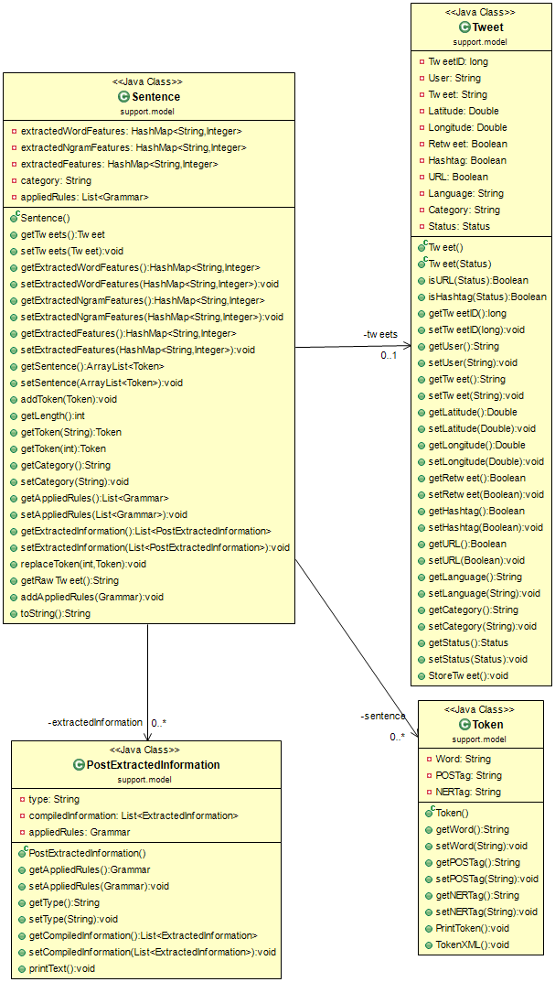

### Rules

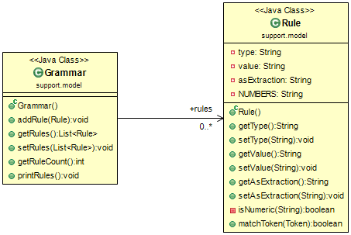

### Extracted Information

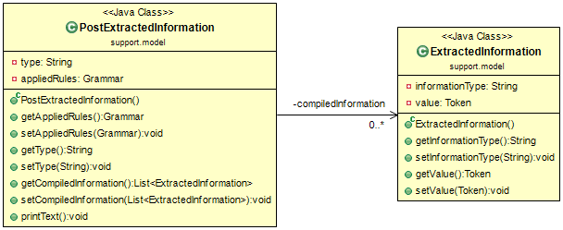

## Crawler Module

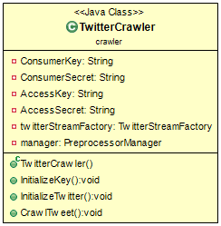

## Information Extraction Engine

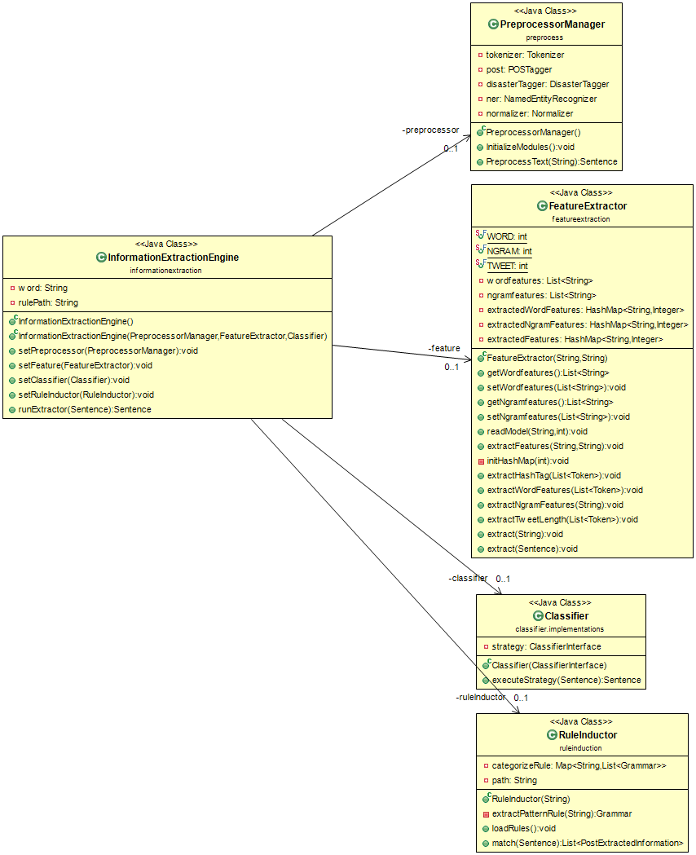

### Preprocessor Manager

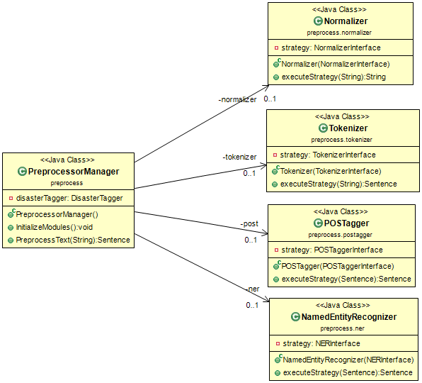

#### Normalizer

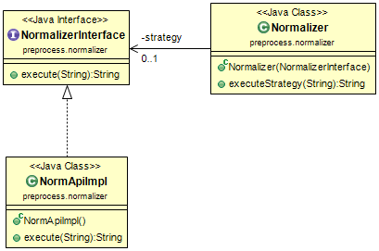

#### Tokenizer

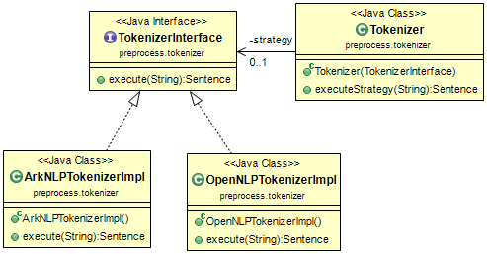

#### POS Tagger

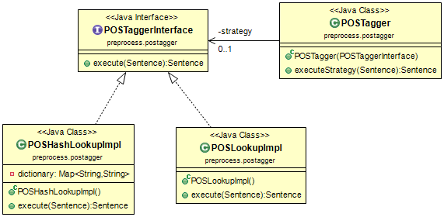

#### NER

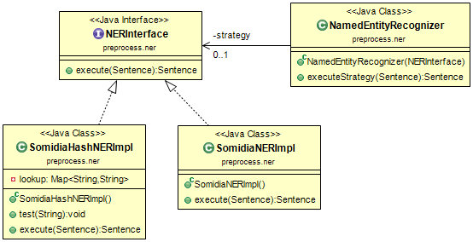

### Feature Extraction Module

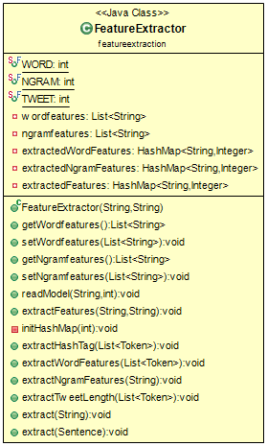

### Classifier Module

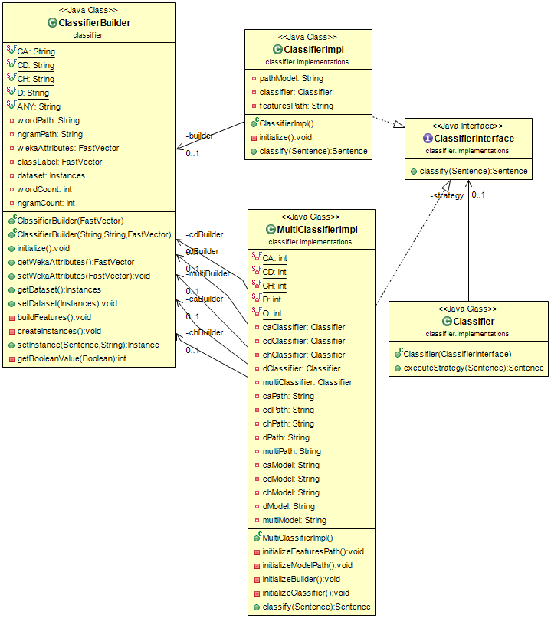

### Rule Inductor Module

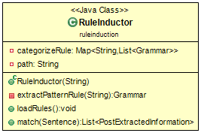

## Ontology

### OntologyModule

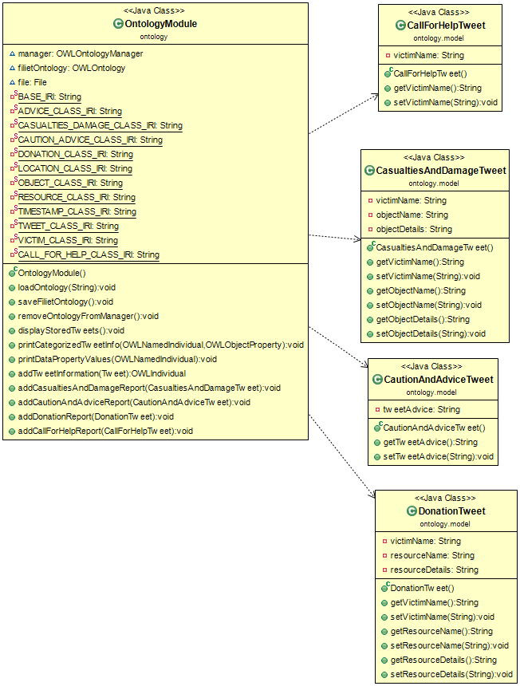

### OntologyRetriever

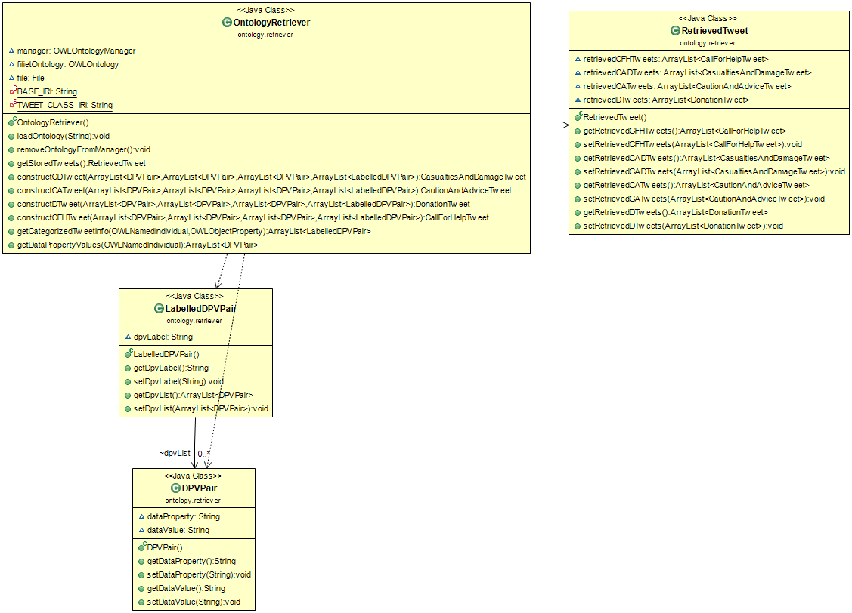

### Binder

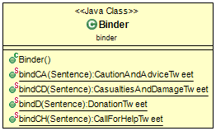

## Others

### Database

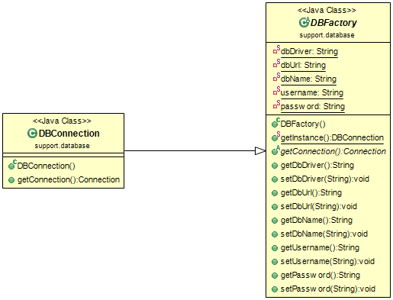

### Reader

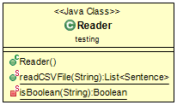

### Language Modeller

#### Document Frequency

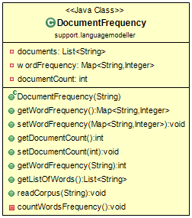

#### WeightScorer

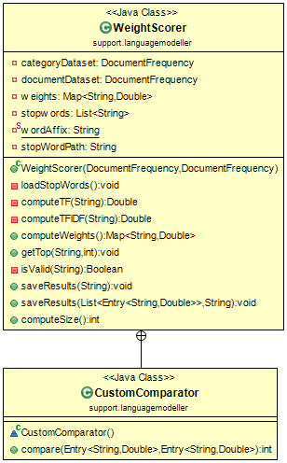

#### N-Gram Modeller

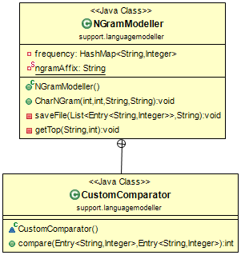

### XML Parser

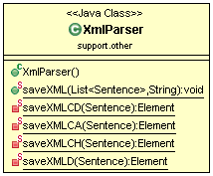

## Entity Relationship Diagram

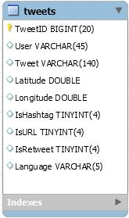

# Class Dictionary

| **Module Name** | **File Name** |
| --- | --- |
| Crawler Module | \filiet-repo\FILIET\resources\db.properties  \filiet-repo\FILIET\resources\twitter.properties  \filiet-repo\FILIET\resources\keywords.txt |
| Preprocessor Module | \filiet-repo\FILIET\resources\NamedEntityRecognizerDictModel  \filiet-repo\FILIET\resources\posDictionary |
| Feature Extraction Module | \filiet-repo\FILIET\resources\model\TFIDF-Scores\mario-ruby\marioruby-word-combined-30.txt |
| Classifier Module | \filiet-repo\FILIET\resources\model\classifier\multiclassifier\mario-marioruby-randomforest-30-model.model  \filiet-repo\FILIET\resources\model\classifier\multiclassifier\mario-rf-ca-30.model  \filiet-repo\FILIET\resources\model\classifier\multiclassifier\mario-rf-cd-30.model  \filiet-repo\FILIET\resources\model\classifier\multiclassifier\mario-rf-ch-30.model  \filiet-repo\FILIET\resources\model\classifier\multiclassifier\mario-rf-d-30.model  \filiet-repo\FILIET\resources\model\TFIDF-Scores\mario-ruby\marioruby-word-combined-30.txt  \filiet-repo\FILIET\resources\model\TFIDF-Scores\mario\archive\mario-word-ca-30.txt  \filiet-repo\FILIET\resources\model\TFIDF-Scores\mario\archive\mario-word-cd-30.txt  \filiet-repo\FILIET\resources\model\TFIDF-Scores\mario\archive\mario-word-ch-30.txt  \filiet-repo\FILIET\resources\model\TFIDF-Scores\mario\archive\mario-word-d-30.txt |
| Rule Inductor | \filiet-repo\FILIET\resources\rules\simple-rules |
| Ontology | \filiet-repo\FILIET\resources\ontology\Ruby_OWL.owl |

## Models

### Tweet Class

|  |  |
| --- | --- |
| **Description** | The Sentence class is the class that holds all information about the tweet instance |
| **Type** | Class |

| **Attributes** | **Data Type** | **Constraint** | **Description** |
| --- | --- | --- | --- |
| TweetID | Long | Private | Stores the ID of the tweet |
| User | String | Private | Stores the author of the tweet |
| Tweet | Double | Private | Stores the message (tweet) |
| Latitude | Double | Private | Stores the latitude where the author posted the tweet (if it is available) |
| Longitude | Double | Private | Stores the longitude where the author posted the tweet (if it is available) |
| Retweet | Boolean | Private | Tells if the tweet is a retweet |
| Hashtag | Boolean | Private | Tells if the tweet contains a hashtag |
| URL | Boolean | Private | Tells if the tweet contains URL link |
| Language | String | Private | Stores the language the tweet is written |
| Category | String | Private | Stores the manually annotated category |
| Status | Status | Private | Stores other information about the tweet (from Twitter4j library) |

| **Method Name** | **Description** | **Parameters** | **Returns** | **Constraint** |
| --- | --- | --- | --- | --- |
| isURL | Tell if the tweet contains URL | Status (Tweet4j) | Boolean | Public |
| isHashtag | Tell if the tweet contains hashtag | Status (Tweet4j) | Boolean | Public |
| getTweetID | Return the tweet ID | Void | Long | Public |
| setTweetID | Sets the tweet ID | Long | Void | Public |
| getUser | Returns the tweet’s author | Void | String – tweet user | Public |
| setUser | Se the tweet’s author | String – tweet user | Void | Public |
| getTweet | Return the message (tweet) | Void | String - tweet | Public |
| setTweet | Sets the message (tweet) | String - tweet | Void | Public |
| getLatitude | Get the location (latitude) | Void | Double - latitude | Public |
| setLatitude | Set the location (latitude) | Double - latitude | Void | Public |
| getLongitude | Get the location (longitude) | Void | Double | Public |
| setLongitude | Set the location (longitude) | Double | Void | Public |
| getRetweet | Return the Retweet’s value | Void | Boolean | Public |
| setRetweet | Set the Retweet value | Boolean | Void | Public |
| getHashtag | Get the Hashtag value | Void | Boolean | Public |
| setHashtag | Set the Hashtag value | Boolean | Void | Public |
| getURL | Get the URL value | Void | Boolean | Public |
| setURL | Set the URL value | Void | Boolean | Public |
| getLanguage | Get the language value | Void | String | Public |
| setLanguage | Set the language value | String | Void | Public |
| getCategory | Get the Category value | Void | String | Public |
| setCategory | Set the Category value | String | Void | Public |
| getStatus | Get the Status object (Twitter 4j) | Void | Status | Public |
| setStatus | Set the Status object (Twitter 4j) | Status | Void | Public |
| StoreTweet | Store the tweet in the database | Void | Void | Public |

### Sentence Class

|  |  |
| --- | --- |
| **Description** | The Sentence class is the class that holds all information about the tweet |
| **Type** | Class |

| **Attributes** | **Data Type** | **Constraint** | **Description** |
| --- | --- | --- | --- |
| extractedWordFeatures | HashMap<String,Integer> | Private | Contains the extracted word features and its frequency. |
| extractedNgramFeatures | HashMap<String, Integer | Private | Contains the extracted n-gram features and its frequency. |
| extractedFeatures | HashMap<String,Integer | Private | Contains other features and its values (Length) |
| appliedRules | List<Grammar> | Private | Contains the list of extraction rules that was applied to the tweet. |
| tweets | Tweet | Private | Contains information about the tweet. |
| sentence | ArrayList<Token> | Private | Contains the tokenized tweet. |
| category | String | Private | The category labelled by the classifier. |
| extractedInformation | List<PostExtractedInformation> | Private | Contains the list of extracted information. |

| **Method Name** | **Description** | **Parameters** | **Returns** | **Constraint** |
| --- | --- | --- | --- | --- |
| getTweets | Gets the Tweet information. | Void | Tweet – the tweet information | Public |
| setTweets | Set the Tweet information. | Tweet – the tweet onformation | Void | Public |
| getExtractedWordFeatures | Get the extracted word features | Void | HashMap<String,Integer> - contains the extracted words and its frequency | Public |
| setExtractedWordFeatures | Set the extracted word features | HashMap<String,Integer> - contains the extracted words and its frequency | Void | Public |
| getExtractedNgramFeatures | Get the extracted n-gram features | Void | HashMap<String,Integer> - contains the extracted n-grams and its frequency | Public |
| setExtractedNgramFeatures | Set the extracted n-gram features | HashMap<String,Integer> extracted n-grams and its frequency | Void | Public |
| getSentence | Get the ArrayList of Tokens (tokenized Tweet) | Void | ArrayList<Token> - tokenized tweets | Public |
| setSentence | Set the ArrayList of Tokens (tokenized Tweet) | ArrayList<Token> - tokenized tweet | Void | Public |
| addToken | Add a token to the ArrayList | Token – a single word | Void | Public |
| getLength | Get the length of the token | Void | Int – number of tokens | Public |
| getToken | Get the specific token with the same word | String – the word to find | Token – returns the token of the word | Public |
| getToken | Get the specific token using index | Int – index of the word | Token – returns the token with the indicated index | Public |
| getExtractedInformation | Get the extracted information | Void | List<PostExtractedInformation> - return the list of extracted information | Public |
| setExtractedInformation | Set the extracted information | List<PostExtractedInformation> - the list of extracted information | Void | Public |
| getCategory | Get the category labelled by the classifier | Void | String | Public |
| setCategory | Sets the category labelled by the classifier | String | Void | Public |
| getRawTweet | Gets the unprocessed tweet | Void | String – the unprocessed tweet | Public |

### Token Class

|  |  |
| --- | --- |
| **Description** | The Token class holds information about a single word. |
| **Type** | Class |

| **Attributes** | **Data Type** | **Constraint** | **Description** |
| --- | --- | --- | --- |
| Word | String | Private | A tokenized word |
| POSTag | String | Private | The Part-of-Speech tag of the word |
| NERTag | String | Private | The entity of the word |

| **Method Name** | **Description** | **Parameters** | **Returns** | **Constraint** |
| --- | --- | --- | --- | --- |
| getWord | Returns the tokenized word | Void | String – the word | Public |
| setWord | Sets the tokenized word | String – the word | Void | Public |
| getPOSTag | Returns the POS Tag of the word | Void | String – POS tag | Public |
| setPOSTag | Sets the POS Tag of the word | String – POS Tag | Void | Public |
| getNERTag | Returns the NER Tag of the word | Void | String – NER Tag | Public |
| setNERTag | Sets the NER Tag of the Word | String – NER tag | Void | Public |
| PrintToken | Prints the word and its POS Tags and NER Tags | Void | Void | Public |

### Rule Class

|  |  |
| --- | --- |
| **Description** | The Rule class represents a token of the extraction rules. |
| **Type** | Class |

| **Attributes** | **Data Type** | **Constraint** | **Description** |
| --- | --- | --- | --- |
| type | String | Private | Tells what kind of extraction to match (POS, NER, or String) |
| value | String | Private | Tells the value that must be matched |
| asExtraction | String | Private | Tells the type of information that will be extracted |
| Sample Rule | | <ner (type): LOCATION (value)>[as]LOCATION (asExtraction) | |

| **Method Name** | **Description** | **Parameters** | **Returns** | **Constraint** |
| --- | --- | --- | --- | --- |
| getType | Return the type value | Void | String – the type of tag to be extracted | Public |
| setType | Set the type attribute | String – the type of tag to be extracted | Void | Public |
| getValue | Return the value value | Void | String – the value to be matched | Public |
| setValue | Set the value attribute | String – the value to be matched | Void | Public |
| getAsExtraction | Return the asExtraction value | Void | String – the type of information that will be extracted | Public |
| setAsExtraction | Set the asExtraction attribute | String – the value to be matched | Void | Public |
| match | Checks if the token matches the rule. | Token – the token to be match | Boolean – returns true if it is a match, fase if not. | Public |

### Grammar Class

|  |  |
| --- | --- |
| **Description** | The Grammar class represents an extraction rules. |
| **Type** | Class |

| **Attributes** | **Data Type** | **Constraint** | **Description** |
| --- | --- | --- | --- |
| rules | List<Rules> | Private | Contains the list of Rule tokens |

| **Method Name** | **Description** | **Parameters** | **Returns** | **Constraint** |
| --- | --- | --- | --- | --- |
| addRule | Add a Rule to the list | Rule - Rule token | Void | Public |
| getRules | Get the extraction rule | Void | List<Rule> - the extraction rule | Public |
| setRules | Set the extraction rule | List<Rule> - the extraction rule | Void | Public |
| getRuleCount | Get the number of Rule tokens | Void | Int – number of rule tokens | Public |
| printRules | Prints the extraction rules | Void | Void | Public |

### ExtractedInformation Class

|  |  |
| --- | --- |
| **Description** | The ExtractedInformation Class represents a token of the extracted information. |
| **Type** | Class |

| **Attributes** | **Data Type** | **Constraint** | **Description** |
| --- | --- | --- | --- |
| informationType | String | Private | Tells the type of information the token is. |
| value | Token | Private | The token that was extracted |

| **Method Name** | **Description** | **Parameters** | **Returns** | **Constraint** |
| --- | --- | --- | --- | --- |
| getInformationType | Return the informationType value | Void | String – the type of information | Public |
| setInformationType | Set the informationType attribute | String – the type of information | Void | Public |
| getValue | Return the value value | Void | Token | Public |
| setValue | Set the value attribute | Token | Void | Public |

### PostInformationExtracted Class

|  |  |
| --- | --- |
| **Description** | The PostInformationExtracted Class represents the extracted information |
| **Type** | Class |

| **Attributes** | **Data Type** | **Constraint** | **Description** |
| --- | --- | --- | --- |
| type | String | Private | Stores the type of information |
| compiledInformation | List<ExtractedInformation> | Private | Stores the extracted information |
| appliedRules | Grammar | Private | Stores the rules that was used to extract the information |

| **Method Name** | **Description** | **Parameters** | **Returns** | **Constraint** |
| --- | --- | --- | --- | --- |
| getAppliedRules | Returns the applied rules | Void | Grammar – the applied rule | Private |
| setAppliedRules | Set the applied rules | Grammar – the applied rule | Void | Private |
| getType | Get the type | Void | String | Private |
| setType | Set the type | String | Void | Private |
| getCompiledInformation | Get the compiledInformation | Void | List<ExtractedInformation> | Private |
| setCompiledInformation | Set the compiledInformation | List<ExtractedInformation> | Void | Private |
| printText | Prints the extracted information | Void | Void | Private |

## Crawler Module

### Crawler Class

|  |  |
| --- | --- |
| **Description** | The Crawler Class collects the Tweets from Twitter. |
| **Type** | Class |

| **Attributes** | **Data Type** | **Constraint** | **Description** |
| --- | --- | --- | --- |
| ConsumerKey | String | Private | This is used to allow the API to make calls to Twitter. |
| ConsumerSecret | String | Private | This is used to allow the API to make calls to Twitter. |
| AccessKey | String | Private | This is the oAuth token to represent the user. |
| AccessSecret | String | Private | This is the oAuth token to represent the user. |
| twitterStreamFactory | TwitterStreamFactory (Twitter4j) | Private | Generates the Twitter streams |

| **Method Name** | **Description** | **Parameters** | **Returns** | **Constraint** |
| --- | --- | --- | --- | --- |
| InitializeKey | Initializes the ConsumerKey, Consumer Secret, AccessKey, and AccessSecret | Void | Void | Private |
| InitializeTwitter | Initializes the TwitterStreamFactory | Void | Void | Private |
| CrawlTweet | Listens to incoming tweets and store them in the database | Void | Void | Public |

## Information Extraction Engine

### InformationEngineExtraction Class

|  |  |
| --- | --- |
| **Description** | The InformationEngineExtraction class integrates the preprocessing module, feature extraction module, classifier module, and the rule inductor module. |
| **Type** | Class |

| **Attributes** | **Data Type** | **Constraint** | **Description** |
| --- | --- | --- | --- |
| word | String | Private | Path to the word features file |
| rulePath | String | Private | Path to the rule list file |
| preprocessor | PreprocessorManager | Private | Handles all the preprocessing of the tweets |
| feature | FeatureExtractor | Private | Extracts the features in the tweet |
| classifier | Classifier | Private | Classifies the tweet into the category |
| ruleInductor | RuleInductor | Private | Applies extraction rules to get the relevant information |

| **Method Name** | **Description** | **Parameters** | **Returns** | **Constraint** |
| --- | --- | --- | --- | --- |
| runExtractor | Runs all the extraction modules. Returns a processed tweet. | String – the tweet | Sentence – processed tweet | Public |
| setPreprocessor | Sets the PreprocessorManager | PreprocessorManager – the preprocessor module | Void | Public |
| setFeature | Sets the FeatureExtraction | FeatureExtractor – the feature extractor module | Void | Public |
| setClassifier | Sets the Classifier | Classifier – the classifier module | Void | Public |
| setRuleInductor | Sets the RuleInductor | RuleInductor – the rule inductor | Void | Public |

## Preprocessing Module

### Preprocessor Manager Class

|  |  |
| --- | --- |
| **Description** | The Preprocessor Manager handles all the preprocessing module |
| **Type** | Class |

| **Attributes** | **Data Type** | **Constraint** | **Description** |
| --- | --- | --- | --- |
| normalizer | Normalizer | Private | Normalizer module |
| tokenizer | Tokenizer | Private | Tokenizer module |
| post | POSTagger | Private | POS Tagger module |
| ner | NamedEntityRecognizer | Private | NER module |

| **Method Name** | **Description** | **Parameters** | **Returns** | **Constraint** |
| --- | --- | --- | --- | --- |
| InitializeModule | Initializes all the preprocessing modules | Void | Void | Private |
| PreprocessText | The raw tweet will be processed through the preprocessing modules | String – the tweet | Sentence – preprocessed tweet | Public |

### Normalizer

#### NormalizerInterface Class

|  |  |
| --- | --- |
| **Description** | The NormalizerInterface class is an interface that tells to implement the executeStrategy() method. |
| **Type** | Interface |

| **Attributes** | **Data Type** | **Constraint** | **Description** |
| --- | --- | --- | --- |
|  |  |  |  |

| **Method Name** | **Description** | **Parameters** | **Returns** | **Constraint** |
| --- | --- | --- | --- | --- |
| executeStrategy | Executes the normalizer | String – raw tweet | Sentence – normalized tweet | Public |

#### Normalizer Class

|  |  |
| --- | --- |
| **Description** | The Normalizer class is the class that implements the NormalizerInterface. |
| **Type** | Class |

| **Attributes** | **Data Type** | **Constraint** | **Description** |
| --- | --- | --- | --- |
| strategy | NormalizerInterface | Private | Stores the implementation that will be used by the executeStrategy method |

| **Method Name** | **Description** | **Parameters** | **Returns** | **Constraint** |
| --- | --- | --- | --- | --- |
| executeStrategy | Executes the normalizer. The Normalizer returns the tweet that has been normalized | String – raw tweet | String – normalized tweet | Public |

#### NormApiImpl Class

|  |  |
| --- | --- |
| **Description** | The NormApiImpl class implements the Tokenizer using the NormAPI |
| **Type** | Class |

| **Attributes** | **Data Type** | **Constraint** | **Description** |
| --- | --- | --- | --- |
|  |  |  |  |

| **Method Name** | **Description** | **Parameters** | **Returns** | **Constraint** |
| --- | --- | --- | --- | --- |
| executeStrategy | Executes the normalizes that uses Norm API | String – raw tweet | String – normalized tweet | Public |

### Tokenizer

#### TokenizerInterface Class

|  |  |
| --- | --- |
| **Description** | The TokenizerInterface class is an interface that tells to implement the executeStrategy() method. |
| **Type** | Interface |

|  |  |  |  |
| --- | --- | --- | --- |
| **Attributes** | **Data Type** | **Constraint** | **Description** |
|  |  |  |  |

| **Method Name** | **Description** | **Parameters** | **Returns** | **Constraint** |
| --- | --- | --- | --- | --- |
| executeStrategy | Executes the tokenizer | String – normalized tweet | Sentence – tokenized tweet | Public |

#### Tokenizer Class

|  |  |
| --- | --- |
| **Description** | The Tokenizer class is the class that implements the TokenizerInterface. |
| **Type** | Class |

| **Attributes** | **Data Type** | **Constraint** | **Description** |
| --- | --- | --- | --- |
| strategy | TokenizerInterface | Private | Stores the implementation that will be used by the executeStrategy method |

| **Method Name** | **Description** | **Parameters** | **Returns** | **Constraint** |
| --- | --- | --- | --- | --- |
| executeStrategy | Executes the tokenizer. Returns a Sentence object that has the tokenized tweet. | String – normalized tweet | Sentence – tokenized tweet | Public |

#### ArkNLPTokenizer Class

|  |  |
| --- | --- |
| Description | The ArkNLPTokenizer class implements the Tokenizer using the ArkNLP library. |
| Type | Class |

|  |  |  |  |
| --- | --- | --- | --- |
| **Attributes** | **Data Type** | **Constraint** | **Description** |
|  |  |  |  |

|  |  |  |  |  |
| --- | --- | --- | --- | --- |
| **Method Name** | **Description** | **Parameters** | **Returns** | **Constraint** |
| executeStrategy | Executes the tokenizer that uses the ArkNLP Tokenizer | String – normalized tweet | Sentence – tokenized tweet | Public |

#### OpenNLPTokenizer Class

|  |  |
| --- | --- |
| **Description** | The OpenNLPTokenizer class implements the Tokenizer using the OpenNLP library. |
| **Type** | Class |

|  |  |  |  |
| --- | --- | --- | --- |
| **Attributes** | **Data Type** | **Constraint** | **Description** |
|  |  |  |  |

|  |  |  |  |  |
| --- | --- | --- | --- | --- |
| **Method Name** | **Description** | **Parameters** | **Returns** | **Constraint** |
| executeStrategy | Executes the tokenizer that uses OpenNLP Tokenizer | String – normalized tweet | Sentence – tokenized tweet | Public |

### POS Tagger

#### POSInterface Class

|  |  |
| --- | --- |
| **Description** | The POSInterface class is an interface that tells to implement the executeStrategy() method. |
| **Type** | Interface |

|  |  |  |  |
| --- | --- | --- | --- |
| **Attributes** | **Data Type** | **Constraint** | **Description** |
|  |  |  |  |

|  |  |  |  |  |
| --- | --- | --- | --- | --- |
| **Method Name** | **Description** | **Parameters** | **Returns** | **Constraint** |
| executeStrategy | Executes the POS Tagger | Sentence – tokenized tweet | Sentence – POS tagged | Public |

#### POSTagger Class

|  |  |
| --- | --- |
| **Description** | The POSTagger class is the class that implements the POSInterface. |
| **Type** | Class |

|  |  |  |  |
| --- | --- | --- | --- |
| **Attributes** | **Data Type** | **Constraint** | **Description** |
| strategy | POSInterface | Public | Stors the implementation that the executeStrategy will use |

| **Method Name** | **Description** | **Parameters** | **Returns** | **Constraint** |
| --- | --- | --- | --- | --- |
| executeStrategy | Executes the POS Tagger. Each token now may contain a POS tag. | Sentence – tokenized tweet | Sentence – POS tagged | Public |

#### POSHashLookupImpl Class

|  |  |
| --- | --- |
| **Description** | The POSHashLookupImpl class implements POS lookup that uses a HashMap |
| **Type** | Class |

| **Attributes** | **Data Type** | **Constraint** | **Description** |
| --- | --- | --- | --- |
| dictionary | HashMap<String,Integer> | Private | Stores the list of words and its corresponding part-of-speech |

|  |  |  |  |  |
| --- | --- | --- | --- | --- |
| **Method Name** | **Description** | **Parameters** | **Returns** | **Constraint** |
| executeStrategy | Executes the POS Tagger using the POS Hash Lookup implementation | Sentence – tokenized tweet | Sentence – POS tagged | Public |

#### POSLookupImpl Class

|  |  |
| --- | --- |
| **Description** | The POSLookupImpl class implements POS lookup. |
| **Type** | Class |

|  |  |  |  |
| --- | --- | --- | --- |
| **Attributes** | **Data Type** | **Constraint** | **Description** |
|  |  |  |  |

|  |  |  |  |  |
| --- | --- | --- | --- | --- |
| **Method Name** | **Description** | **Parameters** | **Returns** | **Constraint** |
| executeStrategy | Executes the POS Tagger using POS Lookup Implementation | Sentence – tokenized tweet | Sentence – POS tagged | Public |

### NER

#### NERInterface Class

|  |  |
| --- | --- |
| **Description** | The NERInterface class is an interface that tells to implement the executeStrategy() method. |
| **Type** | Interface |

|  |  |  |  |
| --- | --- | --- | --- |
| **Attributes** | **Data Type** | **Constraint** | **Description** |
|  |  |  |  |

|  |  |  |  |  |
| --- | --- | --- | --- | --- |
| **Method Name** | **Description** | **Parameters** | **Returns** | **Constraint** |
| executeStrategy | Executes the NER Tagger. Each token now may contain a NER tag. | Sentence – POS Tagged | Sentence – NER tagged | Public |

#### NamedEntityRecognizer Class

|  |  |
| --- | --- |
| Description | The NamedEntityRecognizer class is the class that implements the NERInterface. |
| Type | Class |

|  |  |  |  |
| --- | --- | --- | --- |
| **Attributes** | **Data Type** | **Constraint** | **Description** |
| strategy | NERInterface | Public | Stors the implementation that the executeStrategy will use |

|  |  |  |  |  |
| --- | --- | --- | --- | --- |
| **Method Name** | **Description** | **Parameters** | **Returns** | **Constraint** |
| executeStrategy | Executes the POS Tagger. Each token now may contain a POS tag. | Sentence – POS tagged | Sentence – NER tagged | Public |

#### SomidiaHashNERImpl Class

|  |  |
| --- | --- |
| **Description** | The SomidiaHashNERImpl class implements NER lookup that uses a HashMap |
| **Type** | Class |

|  |  |  |  |
| --- | --- | --- | --- |
| **Attributes** | **Data Type** | **Constraint** | **Description** |
| lookup | HashMap<String,Integer> | Private | Stores the list of words and its corresponding entities |

|  |  |  |  |  |
| --- | --- | --- | --- | --- |
| **Method Name** | **Description** | **Parameters** | **Returns** | **Constraint** |
| executeStrategy | Executes the NER Tagger that uses SOMIDIA Hash Lookup Implementation. | Sentence – POS tagged | Sentence – NER tagged | Public |

#### SomidiaNERImpl Class

|  |  |
| --- | --- |
| **Description** | The SomidiaHashNERImpl class implements NER lookup. |
| **Type** | Class |

|  |  |  |  |
| --- | --- | --- | --- |
| **Attributes** | **Data Type** | **Constraint** | **Description** |
|  |  |  |  |

|  |  |  |  |  |
| --- | --- | --- | --- | --- |
| **Method Name** | **Description** | **Parameters** | **Returns** | **Constraint** |
| executeStrategy | Executes the NER Tagger that uses SOMIDIA Lookup Implementation | Sentence – POS tagged | Sentence – NER tagged | Public |

## Feature Extractor Module

### FeatureExtraction Class

|  |  |
| --- | --- |
| **Description** | The FeatureExtraction Class handles the feature extraction module. |
| **Type** | Class |

| **Attributes** | **Data Type** | **Constraint** | **Description** |
| --- | --- | --- | --- |
| wordfeatures | List<String> | Private | For CSV headers (word features) |
| ngramfeatures | List<String> | Private | For CSV headers (n-gram features) |
| extractedWordfeatures | HashMap<String,Integer> | Private | Stores the extracted word features |
| extractedNgramFeatures | HashMap<String,Integer> | Private | Stores the extracted n-gram features |
| extractedFeatures | HashMap<String,Integer> | Private | Stores the extracted other (tweet length) features |

| **Method Name** | **Description** | **Parameters** | **Returns** | **Constraint** |
| --- | --- | --- | --- | --- |
| getWordFeatures | Return the wordfeatures | Void | List<String> - word features | Public |
| setWordFeatures | Set the wordfeatures | List<String> - word features | Void | Public |
| getNgramFeatures | Return the ngramfeatures | Void | List<String> - ngram features | Public |
| setNgramFeatures | Set the ngramfeatures | List<String> - ngram features | Void | Public |
| readModel | Reads the text file that contained the features to be used | String – path to the features, type – tells if it’s a word features list or n-gram feature list | Void | Public |
| extractWordFeatures | Extract the word features from a tokenized text | List<Token> - tokenized | Void | Public |
| extractNgramFeatures | Extracts the n-gram features from a text | String - untokenized | Void | Public |
| extractTweetLength | Count the length of the tweet | List<Token> - tokenized | Void | Public |
| extract | Extracts the unprocessed instance (used for batch processing) | String – normalized tweet | Void | Public |
| extract | Extracts the feature of a processed instance | Sentence – preprocessed tweet | Sentence – features extracted | Public |
| extractFeatures | Extracts the features of a corpus and save the result into a CSV | String – path, String – save | Void | Public |

## Classifier Module

### ClassifierInterface Class

|  |  |
| --- | --- |
| **Description** | The ClassifierInterface class is an interface that tells to implement the classify() method. |
| **Type** | Interface |

|  |  |  |  |
| --- | --- | --- | --- |
| **Attributes** | **Data Type** | **Constraint** | **Description** |
|  |  |  |  |

|  |  |  |  |  |
| --- | --- | --- | --- | --- |
| **Method Name** | **Description** | **Parameters** | **Returns** | **Constraint** |
| classify | Executes the classifier | Sentence – feature extracted | Sentence – classified tweet | Public |

### ClassifierBuilder Class

|  |  |
| --- | --- |
| **Description** | The ClassifierBuilder Class creates an Instance class that will be used to classify. It sets the values from the feature extraction to the Instance class. |
| **Type** | Class |

|  |  |  |  |
| --- | --- | --- | --- |
| **Attributes** | **Data Type** | **Constraint** | **Description** |
|  |  |  |  |

| **Method Name** | **Description** | **Parameters** | **Returns** | **Constraint** |
| --- | --- | --- | --- | --- |
| Initialize | Initialize the models that will be used for the classification | Void | Void | Public |
| getWekaAttributes | Get the list of attributes | Void | FastVector<String> (Weka) - the features that the classifier will use | Public |
| setWekaAttributes | Set the list of attributes | FastVector<String> (Weka) - the features that the classifier will use | Void | Public |
| getDataset | Get the created Instances class | Void | Instances (Weka) – the header for the Instance | Public |
| setDataset | Set an Instances class | Instances (Weka) – the header for the Instance | Void | Public |
| buildFeatures | Sets the attributes that will be used for classification | Void | Void | Private |
| createInstance | Creates the Instances class | Void | Void | Private |
| setInstance | Set the values for the Instance object | Sentence – the tweet to be classified, String – the type of classifier | Void | Public |
| getBooleanValue | Returns 1 if true, else 0. | Boolean | Int | Private |

### Classifier Class

|  |  |
| --- | --- |
| **Description** | The Classifier Class implements the ClassifierInterface. |
| **Type** | Class |

|  |  |  |  |
| --- | --- | --- | --- |
| **Attributes** | **Data Type** | **Constraint** | **Description** |
| strategy | ClassifierInterface | Private | Stores the implementation that will be used by the executeStrategy method |

|  |  |  |  |  |
| --- | --- | --- | --- | --- |
| **Method Name** | **Description** | **Parameters** | **Returns** | **Constraint** |
| classify | Executes the classify method. The Classifier sets the Category field | Sentence – the feature extracted tweet | Sentence – the classified tweet | Public |

### ClassifierImpl Class

|  |  |
| --- | --- |
| **Description** | The ClassifierImpl Class is a classifier that uses a single classifier. |
| **Type** | Class |

|  |  |  |  |
| --- | --- | --- | --- |
| **Attributes** | **Data Type** | **Constraint** | **Description** |
| pathModel | String | Private | Path to the classifier model |
| classifier | Classifier (Weka) | Private | Classifier that classifies all categories |
| featuresPath | String | Private | Path to the features |
| Builder | ClassifierBuilder | Private | Creates the instance for the classifier |

|  |  |  |  |  |
| --- | --- | --- | --- | --- |
| **Method Name** | **Description** | **Parameters** | **Returns** | **Constraint** |
| Initialize | Initializes the Classifier | Void | Void | Private |
| executeStrategy | Executes the classify method that uses a single classifier implementation. | Sentence – the feature extracted tweet | Sentence – the classified tweet | Public |

### MultiClassifierImpl Class

|  |  |
| --- | --- |
| **Description** | The MultiClassifierImpl Class is a classifier that implements a multiple classifier. The classifier is consist of 5 classifiers, 4 binary classifier for each category, and 1 single classifier. |
| **Type** | Class |

| **Attributes** | **Data Type** | **Constraint** | **Description** |
| --- | --- | --- | --- |
| caClassifier | Classifier (Weka) | Private | Classifier that classifies CA and O |
| cdClassifier | Classifier (Weka) | Private | Classifier that classifies CD and O |
| chClassifier | Classifier (Weka) | Private | Classifier that classifies CH and O |
| dClassifer | Classifier (Weka) | Private | Classifier that classifies D and O |
| multiClassifier | Classifier (Weka) | Private | Classifier that classifies all categories |
| caPath | String | Private | Path to the CA features |
| cdPath | String | Private | Path to the CD features |
| chPath | String | Private | Path to the CH features |
| dPath | String | Private | Path to the D features |
| multiPath | String | Private | Path to the combined features |
| caModel | String | Private | Path to the CA model |
| cdModel | String | Private | Path to the CD model |
| chModel | String | Private | Path to the CH model |
| dModel | String | Private | Path to the D model |
| multiModel | String | Private | Path to the combined model |
| caBuilder | ClassifierBuilder | Private | Creates the instance for the caClassifier |
| cdBuilder | ClassifierBuilder | Private | Creates the instance for the cdClassifier |
| chBuilder | ClassifierBuilder | Private | Creates the instance for the chClassifier |
| dBuilder | ClassifierBuilder | Private | Creates the instance for the dClassifier |
| multiBuilder | ClassifierBuilder | Private | Creates the instance for the multiClassifier |

| **Method Name** | **Description** | **Parameters** | **Returns** | **Constraint** |
| --- | --- | --- | --- | --- |
| executeStrategy | Executes the classify method that uses the multiple classifier implementation. | Sentence – the feature extracted tweet | Sentence – the classified tweet | Public |
| initializeFeaturesPath | Sets the location of the features that will be used | Void | Void | Private |
| initializeModelPath | Sets the location of the models that will be used | Void | Void | Private |
| initializeBuilder | Initializes the ClassifierBuilder class | Void | Void | Private |
| initializeClassifier | Initializes the Classifiers. | Void | Void | Private |

## Rule Induction Module

|  |  |
| --- | --- |
| **Description** | The RuleInductor Class extracts the information from the tweets by matching the rules. |
| **Type** | Class |

|  |  |  |  |
| --- | --- | --- | --- |
| **Attributes** | **Data Type** | **Constraint** | **Description** |
| categorizeRule | Map<String,List<Grammar>> | Private | Contains the list of rules for each category |
| path | String | Private | Path to the rules |

|  |  |  |  |  |
| --- | --- | --- | --- | --- |
| **Method Name** | **Description** | **Parameters** | **Returns** | **Constraint** |
| loadRules | Loads the rules from the text files | Void | Void | Public |
| extractPatternRules | Parse the rules from the text files | String – path file to the rules | Void | Private |
| match | Extracts the information by matching the rules | Sentence - classified tweet | List<PostExtractedInformation> - extracted information | Public |

## Ontology Module

### OntologyModule Class

|  |  |
| --- | --- |
| **Description** | The OntologyModule class is responsible for adding new instances into the ontology. |
| **Type** | Class |

| **Attributes** | **Data Type** | **Constraint** | **Description** |
| --- | --- | --- | --- |
| manager | OwlOntologyManager | Default | The ontology uses a an OWLManager variable to facilitate the maniuplation of the ontology file. |
| filietOntology | OwlOntology | Default | This is the variable that contains the actual OWL file of the ontology. |
| File | File | Default | This is just a variable for containging the OWL file that will be manipulated in the system. |
| BASE_IRI | String | Private | This is a string that contains the Internationalized Resource Identifier of the actual ontology used by the system. |
| ADVICE_CLASS_IRI | String | Private | This is a string that contains the Internationalized Resource Identifier of the Advice class in the actual ontology used by the system. |
| CASUALTIES_DAMAGE_CLASS_IRI | String | Private | This is a string that contains the Internationalized Resource Identifier of the Casualties and Damage class in the actual ontology used by the system. |
| CAUTION_ADVICE_CLASS_IRI | String | Private | This is a string that contains the Internationalized Resource Identifier of the Caurtion and Advice class in the actual ontology used by the system. |
| DONATION_CLASS_IRI | String | Private | This is a string that contains the Internationalized Resource Identifier of the Donation class in the actual ontology used by the system. |
| LOCATION_CLASS_IRI | String | Private | This is a string that contains the Internationalized Resource Identifier of the Location class in the actual ontology used by the system. |
| OBJECT_CLASS_IRI | String | Private | This is a string that contains the Internationalized Resource Identifier of the Object class in the actual ontology used by the system. |
| TIMESTAMP_CLASS_IRI | String | Private | This is a string that contains the Internationalized Resource Identifier of the Timestamp class in the actual ontology used by the system. |
| TWEET_CLASS_IRI | String | Private | This is a string that contains the Internationalized Resource Identifier of the Tweet class in the actual ontology used by the system. |
| VICTIM_CLASS_IRI | String | Private | This is a string that contains the Internationalized Resource Identifier of the Victim class in the actual ontology used by the system. |
| CALL_FOR_HELP_CLASS_IRI | String | Private | This is a string that contains the Internationalized Resource Identifier of the Call For Help class in the actual ontology used by the system. |

| **Method Name** | **Description** | **Parameters** | **Returns** | **Constraint** |
| --- | --- | --- | --- | --- |
| loadOntology | Loads the ontology file to the system’s ontology manager so that it can be manipulated by the system. | Void | Void | Public |
| saveFilietOntology | Save the changes that have been made to the ontology. | Void | Void | Public |
| removeOntologyFromManager | Removes the ontology from the manager to prevent unwanted changes. | Void | Void | Public |
| displayStoredTweets | Display the content of the ontology | Void | Void | Public |
| printCategorizedTweetInfo | This is for checking purposes so that specific information about the tweets that were stored to the ontology can be viewed. | OWLNamedIndividual, OWLObjectProperty | Void | Public |
| printDataPropertyValues | This prints out the value of the specified data properties. | OWLNamedIndividual | Void | Public |
| addTweetInformation | Adds information that are related to the tweets like Location and Timestamp. | Tweet – holds information about the tweet | Void | Public |
| addCasualtiesAndDamageReport | Adds a new instance of a Casualties and Damage tweets into the ontology. | CasualtiesAndDamageTweet – holds information about Casualties and Damage | Void | Public |
| addDonationReport | Adds a new instance of a Donation tweets into the ontology. | DonationTweet – holds information about Donations | Void | Public |
| addCallForHelpReport | Adds a new instance of a Call For Help tweets into the ontology. | CallForHelpTweet – hold information about Call for Help | Void | Public |
| addCautionAndAdviceReport | Adds a new instance of a Cation and Advice tweets into the ontology. | CautionAndAdviceTweet – holds information about Caution and Advice | Void | Public |

### Tweet Class (Ontology)

|  |  |
| --- | --- |
| **Description** | The Tweet (Ontology) Class represents the Tweet information in the ontology |
| **Type** | Class |

|  |  |  |  |
| --- | --- | --- | --- |
| **Attributes** | **Data Type** | **Constraint** | **Description** |
| tweetHandle | String | Private | Stores the tweet’s author |
| tweetContent | String | Private | Stores the message (tweet) |
| tweetGeoLocation | String | Private | Stores the location where the tweet was sent (latitude, longitude |
| locationInTweet | String | Private | Stores the location that was extracted in the tweet |
| tweetTimestamp | String | Private | Stores the tweet’s timestamp |
| tweetDate | String | Private | Stores the tweet’s date |

| **Method Name** | **Description** | **Parameters** | **Returns** | **Constraint** |
| --- | --- | --- | --- | --- |
| getTweetHandle | Get the tweet handle | Void | String | Public |
| setTweetHandle | Set the tweet handle | String | Void | Public |
| getTweetContent | Get the tweet content | Void | String - tweet | Public |
| setTweetContent | Set the tweet content | String - tweet | Void | Public |
| getTweetGeoLocation | Get the tweet’s geolocation (latitude, longitude) | Void | String - latitude and longitude (Format: Latitude, Longitude) | Public |
| setTweetGeoLocation | Set the tweet’s geolocation (latitude, longitude) | String – latitude and longitude (Format: Latitude, Longitude) | Void | Public |
| getLocationInTweet | Get the locationInTweet | Void | String – extracted location in tweet | Public |
| setLocationInTweet | Set the locationInTweet | String – extracted location in tweet | Void | Public |
| getTweetTimestamp | Get the tweet timestamp | Void | String – timestamp of the tweet | Public |
| setTweetTimestamp | Set the tweet timestamp | String – timestamp of the tweet | Void | Public |
| getTweetDate | Get the tweet date | Void | String – date of the tweet | Public |
| setTweetDate | Set the tweet date | String – date of the tweet | Void | Public |

### CallForHelpTweet Class

|  |  |
| --- | --- |
| **Description** | The CallForHelpTweet Class represents the Call For Help category in the ontology. |
| **Type** | Class |
| **Inherited** | Tweet (Ontology) Class |

|  |  |  |  |
| --- | --- | --- | --- |
| **Attributes** | **Data Type** | **Constraint** | **Description** |
| victimName | String | Private | Stores the extracted victim name in the tweet. |

|  |  |  |  |  |
| --- | --- | --- | --- | --- |
| **Method Name** | **Description** | **Parameters** | **Returns** | **Constraint** |
| getVictimName | Get the victim name | Void | String – extracted victim name | Public |
| setVictimName | Set the victim name | String – extracted victim name | Void | Public |

### CasualtiesAndDamageTweet Class

|  |  |
| --- | --- |
| **Description** | The CasualtiesAndDamageTweet Class represents the Casualties and Damage category in the ontology. |
| **Type** | Class |
| **Inherited** | Tweet (Ontology) Class |

|  |  |  |  |
| --- | --- | --- | --- |
| **Attributes** | **Data Type** | **Constraint** | **Description** |
| victimName | String | Public | Stores the extracted victim name in the tweet. |
| objectName | String | Public | Stores the extracted object that was destroyed in the tweet |
| objectDetails | String | Public | Stores the detail about the object |

|  |  |  |  |  |
| --- | --- | --- | --- | --- |
| **Method Name** | **Description** | **Parameters** | **Returns** | **Constraint** |
| getVictimName | Get the victim name | Void | String – extracted victim name | Public |
| setVictimName | Set the victim name | String – extracted victim name | Void | Public |
| getObjectName | Get the object name | Void | String – extracted object | Public |
| setObjectName | Set the object name | String – extracted object | Void | Public |
| getObjectDetails | Get the object details | Void | String – extracted detail about the object | Public |
| setObjectDetails | Set the object details | String – extracted detail about the object | Void | Public |

### CautionAndAdviceTweet Class

|  |  |
| --- | --- |
| **Description** | The CautionAndAdviceTweet Class represents the Caution and Advice category in the ontology. |
| **Type** | Class |
| **Inherited** | Tweet (Ontology) Class |

|  |  |  |  |
| --- | --- | --- | --- |
| **Attributes** | **Data Type** | **Constraint** | **Description** |
| tweetAdvice | String | Private | Stores the extracted advice in the tweet |

| **Method Name** | **Description** | **Parameters** | **Returns** | **Constraint** |
| --- | --- | --- | --- | --- |
| getTweetAdvice | Get the tweet advice | Void | String – extracted advice | Public |
| setTweetAdvice | Set the tweet advice | String – extracted advice | Void | Public |

### DonationTweet Class

|  |  |
| --- | --- |
| **Description** | The DonationTweet Class represents the Donation category in the ontology. |
| **Type** | Class |
| **Inherited** | Tweet (Ontology) Class |

|  |  |  |  |
| --- | --- | --- | --- |
| **Attributes** | **Data Type** | **Constraint** | **Description** |
| victimName | String | Public | Stores the extracted victim name in the tweet. |
| resourceName | String | Public | Stores the extracted resource that was donated in the tweet |
| resourceDetail | String | Public | Stores the details about the resource |

|  |  |  |  |  |
| --- | --- | --- | --- | --- |
| **Method Name** | **Description** | **Parameters** | **Returns** | **Constraint** |
| getVictimName | Get the victim name | Void | String – extracted victim | Public |
| setVictimName | Set the victim name | String – extracted victim | Void | Public |
| getResourceName | Get the resource name | Void | String – extracted resource | Public |
| setResourceName | Set the resource name | String – extracted resource | Void | Public |
| getResourceDetail | Get the resource detail | Void | String – extracted resource detail | Public |
| setResourceDetail | Set the resource detail | String – extracted resource detail | Void | Public |

### OntologyRetriever Class

|  |  |
| --- | --- |
| **Description** | The RuleInductor Class extracts the information from the tweets by matching the rules. |
| **Type** | Class |

|  |  |  |  |
| --- | --- | --- | --- |
| **Attributes** | **Data Type** | **Constraint** | **Description** |
|  |  |  |  |

|  |  |  |  |  |
| --- | --- | --- | --- | --- |
| **Method Name** | **Description** | **Parameters** | **Returns** | **Constraint** |
| loadOntology | Loads the ontology file to the system’s ontology manager so that it can be manipulated by the system. | Void | Void | Public |
| removeOntologyFromManager | Removes the ontology filefrom the manager so that no unwanted changes can be made to the ontology. | Void | Void | Public |
| getStoredTweets | Retrieves the tweets stored in the ontology. | Void | RetrievedTweet – the tweet in the ontology | Public |
| constructCDTweet | Constructs the CD tweet based from the different information extracted so that it can be manipulated within the system. | ArrayList<DPVPair>, ArrayList<DPVPair>, ArrayList<DPVPair>, ArrayList<LabelledDPVPair> | CasualtiesAndDamageTweet | Public |
| constructCATweet | Constructs the CA tweet based from the different information extracted so that it can be manipulated within the system. | ArrayList<DPVPair>, ArrayList<DPVPair>, ArrayList<DPVPair>, ArrayList<LabelledDPVPair> | CautionAndAdviceTweet | Public |
| constructCHTweet | Constructs the CH tweet based from the different information extracted so that it can be manipulated within the system. | ArrayList<DPVPair>, ArrayList<DPVPair>, ArrayList<DPVPair>, ArrayList<LabelledDPVPair> | CallForHelpTweet | Public |
| constructDTweet | Constructs the D tweet based from the different information extracted so that it can be manipulated within the system. | ArrayList<DPVPair>, ArrayList<DPVPair>, ArrayList<DPVPair>, ArrayList<LabelledDPVPair> | DonationTweet | Public |

### DPVPair Class

|  |  |
| --- | --- |
| **Description** | This is a class that stores a pair of data properties and their respective values as they are retrieved from the ontology. This is a simple implementation to minimize the need for using hashmaps for accessing this types of data. |
| **Type** | Class |

|  |  |  |  |
| --- | --- | --- | --- |
| **Attributes** | **Data Type** | **Constraint** | **Description** |
| dataProperty | String | Default | This string contains the name of the data property. |
| dataValue | String | Default | This string contains the actual value for the specified data property. |

|  |  |  |  |  |
| --- | --- | --- | --- | --- |
| **Method Name** | **Description** | **Parameters** | **Returns** | **Constraint** |
| getDataProperty | Get the data property | Void | String – data property | Public |
| SetDataProperty | Set the data property | String – data property | Void | Public |
| getDataValue | Get the data value | Void | String – value of the data property | Public |
| setDataValue | Set the data value | String – value of the data property | Void | Public |

### LabelledDPVPair Class

|  |  |
| --- | --- |
| **Description** | This class is for labelling the list of data property value pairs. |
| **Type** | Class |

| **Attributes** | **Data Type** | **Constraint** | **Description** |
| --- | --- | --- | --- |
| dpvLabel | String | Default | This contains the name of the list of data property value pairs. |
| dpvList | ArrayList<DPVPair> | Default | This is a list of data property value pairs. |

|  |  |  |  |  |
| --- | --- | --- | --- | --- |
| **Method Name** | **Description** | **Parameters** | **Returns** | **Constraint** |
| getDpvLabel | Get the DPV Label | Void | String | Public |
| setDpvLabel | Set the DPV Label | String | Void | Public |
| getDpvList | Get the DPV List | Void | ArrayList<DPVPair> | Public |
| setDpvList | Set the DPV List | ArrayList<DPVPair> | Void | Public |

### RetrievedTweet Class

|  |  |
| --- | --- |
| **Description** | This is a class that compiles the different arraylist of the tweets that were retrieved from the ontology. |
| **Type** | Class |

| **Attributes** | **Data Type** | **Constraint** | **Description** |
| --- | --- | --- | --- |
| retrievedCFHTweets | ArrayList<CallForHelpTweet> | Default | This is the ArrayList that contains tweet contains Call For Help tweet instances. |
| retrievedCADTweets | ArrayList<CasualtiesAndDamageTweet> | Default | This is the ArrayList that contains tweet contains Casualties and Damage tweet instances. |
| retrievedCATweets | ArrayList<CautionAndAdviceTweet> | Default | This is the ArrayList that contains tweet contains Caution and Advice tweet instances. |
| retrievedDtweets | ArrayList<DonationTweet> | Default | This is the ArrayList that contains tweet contains Donation tweet instances. |

| **Method Name** | **Description** | **Parameters** | **Returns** | **Constraint** |
| --- | --- | --- | --- | --- |
| getRetrievedCFHTweets | Gets the list of Call For Help tweets. | Void | ArrayList<CallForHelpTweet> - list of Call For Help tweets | Public |
| setRetrievedCFHTweets | Sets the list of Call For Help tweets. | ArrayList<CallForHelpTweet> - list of Call For Help tweets | Void | Public |
| getRetrievedCADTweets | Gets the list of Casualties and Damage tweets. | Void | ArrayList<CasualtiesAndDamageTweet> - list of Casualties and Damage tweets | Public |
| setRetrievedCADTweets | Sets the list of Casualties and Damage tweets. | ArrayList<CasualtiesAndDamageTweet> - list of Casualties and Damage tweets | Void | Public |
| getRetrievedCATweets | Gets the list of Caution and Advice tweets. | Void | ArrayList<CautionAndAdviceTweet> - list of Caution and Advice tweets | Public |
| setRetrievedCATweets | Sets the list of Caution and Advice tweets. | ArrayList<CautionAndAdviceTweet> - list of Caution and Advice tweets | Void | Public |
| getRetrievedDTweets | Gets the list of Donation tweets. | Void | ArrayList<DonationTweet> - list of Donation tweets | Public |
| setRetrievedDTweets | Sets the list of Donation tweets. | ArrayList<DonationTweet> - list of Donation tweets | Void | Public |

### Binder Class

|  |  |
| --- | --- |
| **Description** | The Binder Class maps the extracted information to its corresponding Ontology models that will be used to input into the ontology. |
| **Type** | Class |

|  |  |  |  |
| --- | --- | --- | --- |
| **Attributes** | **Data Type** | **Constraint** | **Description** |
|  |  |  |  |

| **Method Name** | **Description** | **Parameters** | **Returns** | **Constraint** |
| --- | --- | --- | --- | --- |
| bindCA | Maps the Sentence object to the CautionAndAdviceTweet | Sentence – CA labelled | CautionAndAdviceTweet – binded information | Public |
| bindCD | Maps the Sentence object to the CasualtiesAndDamageTweet | Sentence – CD labelled | CasualtiesAndDamageTweet – binded information | Public |
| bindCH | Maps the Sentence object to the CallForHelpTweet | Sentence – CH labelled | CallForHelpTweet – binded information | Public |
| bindD | Maps the Sentence object to the DonationTweet | Sentence – D labelled | DonationTweet – binded information | Public |

## Others

### DBFactory Class

|  |  |
| --- | --- |
| **Description** | The DBFactory Class handles the creation of connection to the database. |
| **Type** | Abstract |

| **Attributes** | **Data Type** | **Constraint** | **Description** | |
| --- | --- | --- | --- | --- |
| dbDriver | String | Private | Driver of the database | |
| dbUrl | String | Private | URL of the database | |
| dbName | String | Private | Database name | |
| username | String | Private | Username of the database | |
| password | String | Private | Password of the database | |
| Method Name | Description | Parameters | Returns | Constraint |
| getConnection | Creates the connection | Void | Connection (JDBC) – provides the connection to the MySQL server | Abstract |
| getInstance | Creates a DBConnection instance | Void | DBConnection – DB Connection factory | Public |
| getDbDriver | Get the dbDriver value | Void | String – the database driver | Public |
| setDbDriver | Set the dbDriver value | String – the database driver | Void | Public |
| getUrl | Get the dbUrl value | Void | String – the URL of database | Public |
| setUrl | Set the dbUrl value | String – the URL of database | Void | Public |
| getDbName | Get the dbName value | Void | String – the database name | Public |
| setDbName | Set the dbName value | String – the database name | Void | Public |
| getUsername | Get the username value | Void | String – username | Public |
| setUsername | Set the username value | String – username | Void | Public |
| getPassword | Get the password value | Void | String - password | Public |
| setPassword | Set the password value | String - password | Void | Public |

### DBConnection Class

|  |  |
| --- | --- |
| **Description** | The DBConnection Class generates the connection to the database. |
| **Type** | Class |

|  |  |  |  |
| --- | --- | --- | --- |
| **Attributes** | **Data Type** | **Constraint** | **Description** |
|  |  |  |  |

|  |  |  |  |  |
| --- | --- | --- | --- | --- |
| **Method Name** | **Description** | **Parameters** | **Returns** | **Constraint** |
| getConnection | Creates the connection to the server | Void | Connection – connection to the database | Public |

### Reader Class

|  |  |
| --- | --- |
| **Description** | The Reader Class reads the CSV File |
| **Type** | Class |

|  |  |  |  |
| --- | --- | --- | --- |
| **Attributes** | **Data Type** | **Constraint** | **Description** |
|  |  |  |  |

| **Method Name** | **Description** | **Parameters** | **Returns** | **Constraint** |
| --- | --- | --- | --- | --- |
| readCSVFile | Reads the CSV file that contain the tweet corpus | String – path the corpus | List<Sentence> - parsed CSV file | Public |

### XmlParser Class

|  |  |
| --- | --- |
| **Description** | The XmlParser Class is responsible for reading and writing XML |
| **Type** | Class |

|  |  |  |  |
| --- | --- | --- | --- |
| **Attributes** | **Data Type** | **Constraint** | **Description** |
|  |  |  |  |

| **Method Name** | **Description** | **Parameters** | **Returns** | **Constraint** |
| --- | --- | --- | --- | --- |
| saveXML | Save the results of the information extraction in a XML file. | List<Sentence> - processed sentences, String - output | Void | Public |
| saveXMLCA | Create a XML node for CA instance | CautionAndAdviceTweet – binded Caution and Advice | Element – written to the XML | Private |
| saveXMLCD | Create a XML node for CD instance | CasualtiesAndDamageTweet - binded Casualties and Damage | Element – written to the XML | Private |
| saveXMLCH | Create a XML node for CH instance | CallForHelpTweet – binded Call for Help | Element – written to the XML | Private |
| saveXMLD | Create a XML node for CD instance | DonationTweet – binded Donation | Element – written to the XML | Private |

### DocumentFrequency Class

|  |  |
| --- | --- |
| **Description** | The DocumentFrequency Class provides the word and its frequency of a corpus. |
| **Type** | Class |

|  |  |  |  |
| --- | --- | --- | --- |
| **Attributes** | **Data Type** | **Constraint** | **Description** |
| documents | List<Sentence> | Private | Contains the tweet corpora |
| wordFrequency | HashMap<String,Integer> | Private | Contains the list of words and its corresponding frequency |
| documentCount | Int | Private | The number of instance in the corpus |

| **Method Name** | **Description** | **Parameters** | **Returns** | **Constraint** |
| --- | --- | --- | --- | --- |
| getWordFrequency | Get the wordFrequency | Void | Map<String,Integer> - list of words and its frequency | Public |
| setWordFrequency | Set the wordFrequency | Map<String,Integer> - list of words and its frequency | Void | Public |
| getDocumentCount | Get the document count | Void | Int – number of corpus | Public |
| setDocumentCount | Set the document count | Int – number of corpus | Void | Public |
| getWordFrequency | Gives the count of the word | String - word | Int – number of occurences in the corpus | Public |
| getListOfWords | Get the list of distinct words from the corpus | Void | List<String> - list of words | Public |
| readCorpus | Reads the CSV file that contains the corpus | String – path to the corpus | Void | Public |
| countWordsFrequency | Counts the frequency of the words in the corpus | Void | Void | Public |

### WeightScorer Class

|  |  |
| --- | --- |
| **Description** | The WeightScorer Class measures the TF-IDF scores of the words |
| **Type** | Class |

| **Attributes** | **Data Type** | **Constraint** | **Description** |
| --- | --- | --- | --- |
| categoryDataset | DocumentFrequency | Private | Contains the list of word and its frequency of the category dataset. (Dataset that only contained 1 category) |
| documentDataset | DocumentFrequency | Private | Contains the list of words and its frequency of the whole dataset |
| Weights | Map<String,Double> | Private | List of words and its computed TF-IDF Scores |
| stopwords | List<String> | Private | List of stop words |
| stopWordPath | String | Private | Path to the list of stop words |

| **Method Name** | **Description** | **Parameters** | **Returns** | **Constraint** |
| --- | --- | --- | --- | --- |
| loadStopWords | Load the list of stop words | Void | Void | Private |
| computeTF | Computes the term frequency | String – the word to be computed | Double – computed term frequency | Private |
| computeTFIDF | Computes the TF-IDF of a word | String – the word to be computed | Double – computed term frequency – inverted document frequency | Private |
| computeWeights | Computes the TFIDF scores of all the words in the list | Void | Map<String,Double> - list of words and its computed TFIDF score | Public |
| getTop | Get the words with the top N TF-IDF scores | String – savePath, int – top N | Void | Public |
| isValid | Checks if the word is valid | String - word | Boolean – checks if the word does not contain special characters, links, diacritics | Private |
| saveResults | Save the results to a text file | List<Map.Entry<String,Double>> - list of words, String - outputPath | Void | Public |
| saveResults | Save the results to a text file | String – outputPath | Void | Public |
| computeSize | Returns the size of the Weight attribute | Void | Int – number of distinct word in the corpus | Public |

### NGramModeller Class

|  |  |
| --- | --- |
| **Description** | The NGramModeller Class produces the top highest frequency n-grams. |
| **Type** | Class |

|  |  |  |  |
| --- | --- | --- | --- |
| **Attributes** | **Data Type** | **Constraint** | **Description** |
|  |  |  |  |

|  |  |  |  |  |
| --- | --- | --- | --- | --- |
| **Method Name** | **Description** | **Parameters** | **Returns** | **Constraint** |
| CharNGram | counts the frequency of n-gram | Int – n-gram, double - topN, String – saveFile, String path - corpus | Void | Public |
| saveFile | Save the list to a file | List<Map.Entry<String,Integer>> - list of n-gram and its frequency, String – save path | Void | Private |
| getTop | Get the top N highest ngram frequency. Result is save to a file. | String – save file, int - top N | Void | Private |

### Filter Class

|  |  |
| --- | --- |
| **Description** | The Filter Class is used to clean the words. |
| **Type** | Class |

|  |  |  |  |
| --- | --- | --- | --- |
| **Attributes** | **Data Type** | **Constraint** | **Description** |
|  |  |  |  |

| **Method Name** | **Description** | **Parameters** | **Returns** | **Constraint** |
| --- | --- | --- | --- | --- |
| hasSpecialCharacters | Check if the word contains special characters | String - word | Boolean – check if the word contains special characters | Public |
| hasLinks | Check if the word is a link | String - word | Boolean – check if the word is a link | Public |
| hasDiacritics | Check if the word contains diacritics | String - word | Boolean – check if the word contains diacritic | Public |
| isNumeric | Check if the word is numeric | String – word | Boolean – check if the word is a number | Public |
| removeNonAlphaNumeric | Removes the special characters in the string | String - word | String – removes the special characters | Public |